ÇARIKLAR SECONDARY SCHOOL – 5th GRADEs - 1ST TERM 1ST ENGLISH EXAM (2020-2021)
- Write the words under the correct pictures. (Kelimeleri doğru resmin altına yerleştiriniz.) (16p)
LOVE | PHSICAL EDUCATION | HI/HELLO | SCIENCE
MATH | ART | PLAY TABLE TENNIS | LANGUAGE
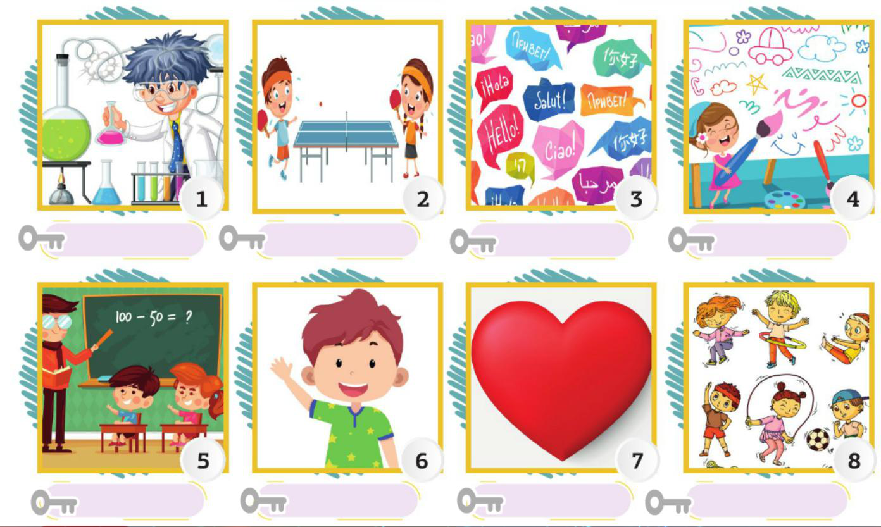

- ANSWER THE QUESTİONS BELOW. (Aşağıdaki soruları cevaplayınız.) (10p)

- What is your name? D. What is your favorite lesson/class?
…………………………………………….. …………………………………………………….

- How are you? E. How OLD are you?
…………………………………………….. …………………………………………………….
- Where are you from?
……………………………………………..
- Choose the correct option. (Doğru olan cevabı seçiniz.) (8p)

- Classroom A) Phsical education
- Name B) Art
- Country C) Science
- Timetable D) History

- Circle the od done. (Farklı olanı seçiniz.) (10p)
- a. Monday b. Turkey c. Japan d. U.S.A
- a. Love b. Hate c. Dislike d. don’t like
- a. Science b. Enjoy c. Math d. Art
- a. Italian b. Indian c. Spanish d. Turkey
- a. Play the piano b. Do experiment c. Play football d. Hate

- Match the words with the pictures. (Kelimlerle resimleri eşleştiriniz.) (20p)

PARK | LIBRARY | THEATRE | STATIONARY | PLAYGROUND
BAKERY | PHARMACY | TOWN | POLICE STATION | MUSEUM
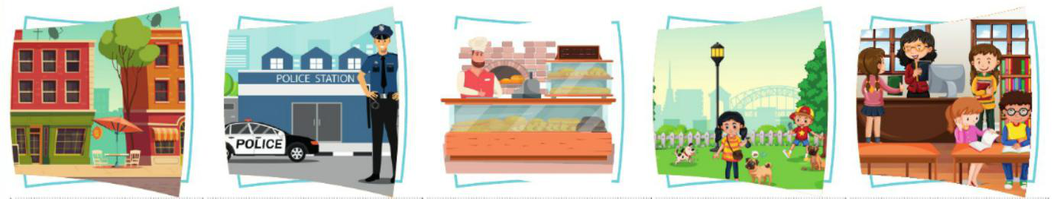

…………………………. …………………………. …………………………. …………………………. ………………………….

…………………………. …………………………. …………………………. …………………………. ………………………….
- Boşlukları “like ”- “don’t like” - “doesn’t like” – “dislike” ya da “hate” ile doldurunuz. (20p)
1. I ……………… English very much. |  | 6. We ……………… jumping.
2. My father ……………… drinking tea. |  | 7. She ……………… climbing tree.
3. Dilan ……………… swimming. |  | 8. Asya ……………… riding bicyle.
4. They ……………… playing golf. |  | 9. You ……………… sleeping.
5. Nazan ……………… watching cartoon. |  | 10. My brother ……………… going to school.

- Choose the right options below. (Aşağıdaki doğru olan seçenekleri seçiniz.) (16p)
- Our favourite class is phsical education. 3. I love ……………. at school. English, Spanish and
We always play sports and ………………. Turkish are my favourite.
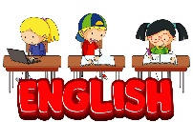
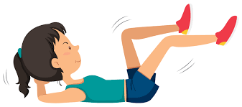
It is sof un.
- Art
- Social Studies
- Phsical Education
- Play the guitar C) do exercises D) Music
- Read a book D) do experiment

- I ……………. Music class. Playing the guitar and 4. Ali : Where are you now?
singing songs are my favourite. Sandy: I am in the …….. I read some books here.

- HATE B) LOVE C) DISLIKE D) GO A) Museum B) School C) Hotel D) Library
English Teacher: Samet SAYGI

