**…………………….. EDUCATIONAL YEAR ………………….. SECONDARY SCHOOL**

**1st TERM 1stENGLISH EXAM FOR 5TH GRADES**

**NAME SURNAME:…………………………………………................. Class:………… Point:……………**

**1)MATCH THE QUESTIONS WITH THEIR ANSWERS. (SORULARLA CEVAPLARI EŞLEŞTİRİNİZ.)(10 PTS)**

1. What is your name? ………………… I am eleven years old.

2. Where are you from? ………………… I am English.

3. What nationality are you? ………………… My name is Sally.

4. How old are you? ……………….. I am from Germany

5. How are you? ……………….. Fine, thanks and you.

**2) COMPLETE THE TABLE ACCORDING TO THE SPEECH BUBBLE. (TABLOYU PARÇAYA GÖRE TAMAMLAYINIZ) (16 PTS)**

|  |
| --- |
| **Name:** |
| **Age:** |
| **Country:** |
| **Nationality:** |
| **Languages:** |
| **Favourite lessons:** |
| **Likes:** |
| **Dislikes:** |

Hello!

My name is Alfred. I am 13 years old. I am from Germany and I am German. I speak English and German languages. My favourite lessons are Music and P.E. He likes Music and P.E. but he doesn’t like Maths class.



**3) MATCH THE COUNTRIES WITH THE NATIONALITIES. (ÜLKELER VE MİLLETLERİ EŞLEŞTİRİNİZ) (14 PTS)**

|  |  |
| --- | --- |
| **Country** | **Nationality** |
| 1)Turkey | _____ German |
| 2) Spain | _____ English |
| 3) France | _____ French |
| 4) Germany | _____ Japanese |
| 5) Italy | _____ Spanish |
| 6) England | _____ Italian |
| 7) Japan | _____ Turkish |

**4)COMPLETE THE TABLE. (TABLOYU PARÇAYA GÖRE TAMAMLAYINIZ.) (20 PTS)**



Hello,my name is Ezgi.I’m a student at a secondary school.I’m 12 years old.This is my week lyschedule.I have double Maths and double Science on Monday.

I have Music,Drama and double P.E. on Tuesday.

I have double Social Studies and double English on Wednesday.

I have doubleTurkish and double Art on Thursday.

I have double Geography and double History on Friday.

|  |  |  |  |  |
| --- | --- | --- | --- | --- |
| **MONDAY** | **TUESDAY** | **WEDNESDAY** | **THURSDAY** | **FRIDAY** |
|  |  |  |  |  |
|  |  |  |  |  |
|  |  |  |  |  |
|  |  |  |  |  |

**5) LOOK AT AND COMPLETE THE SENTENCES WITH “NEXT TO, BEHIND, BETWEEN, IN FRONT OF, ON, IN, UNDER.” (14 PTS)**

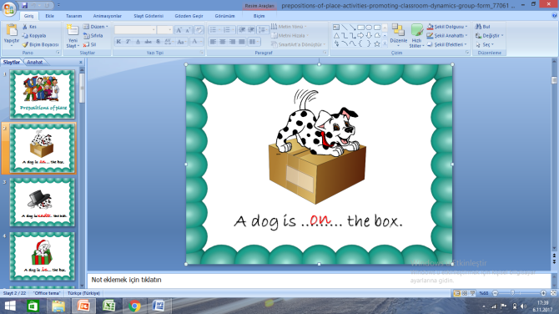**A dog is ...........thebox. 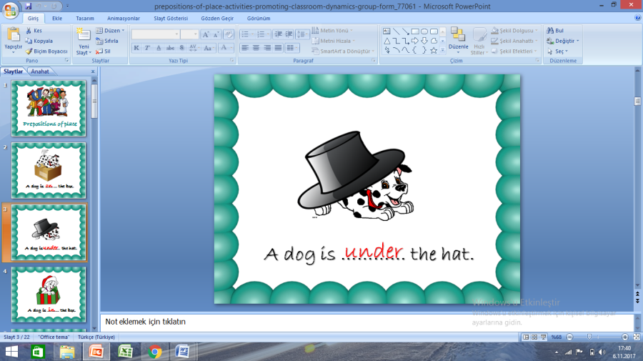A dog is ........the hat.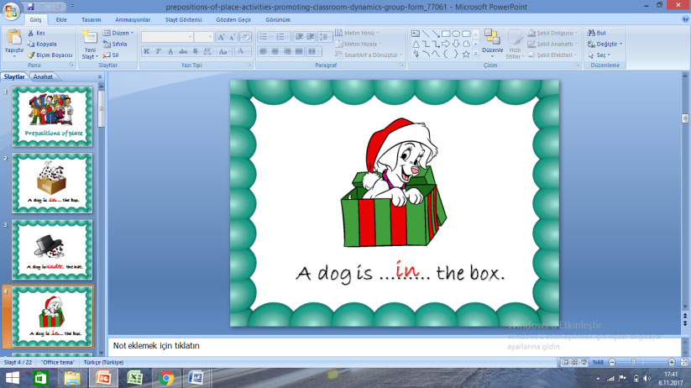 A dog is ........the box.**

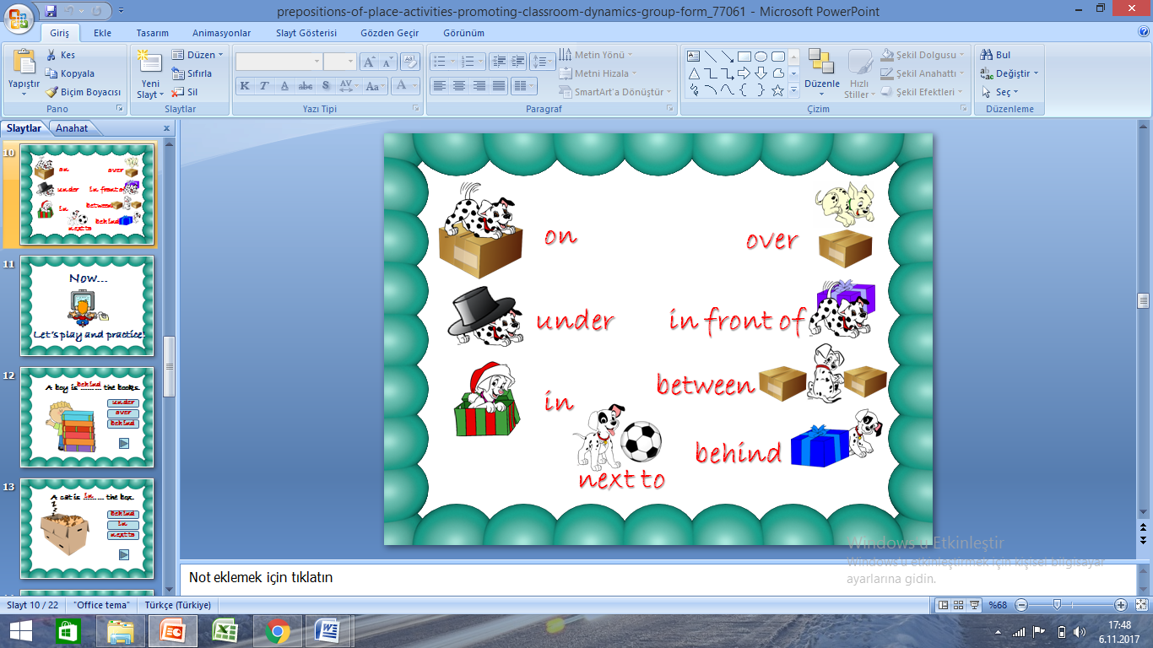**A dog is ............thebox. A dog is .........the box.A dog is ..........the ball.**

** A dog is ........................the boxes.**

**6) MATCH THE PICTURES WITH THEIR NAMES. (20 PTS)**

*Library - swimming pool - hospital - bakery - pharmacy*

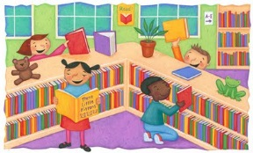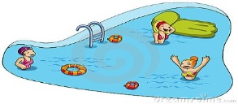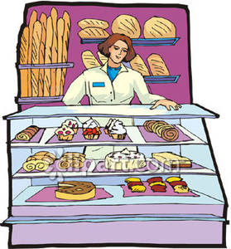

*………………………. ……………………. ……………………. …………………….. ……………………………*

***Physical education - Science - Social studies - English - Art***

   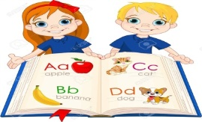 

***…………….. ………………… …………………… ………………….. ………………………..***

**E: LOOK AT THE MAP, FOLLOW THE DIRECTİONS AND FIND THE PLACES.(HARİTAYA BAKARAK TARİFE GÖRE GİTMENİZ GEREKEN YER İSMİNİ BOŞLUĞA YAZINIZ.) (10 PTS)**

1. Go straight ahead. Turn left into the Gazi Street. It is next to the café: _____________________
2. Go along Bağdat Street.Turnright into the Gazi Street. It is opposite the bus station: _________
3. Go along Bağdat Street. Turn left into İstiklal Street. It’s opposite the bank**:**______________
4. Go straight ahead.Turn right into İstiklal Street. It’s next to the cinema:____________________
5. Go straight ahead and turn right into Gazi Street. It’s opposite the hospital and next to the bus station.________________________

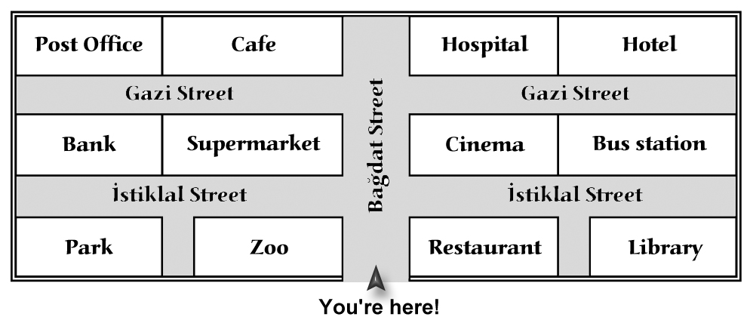

**DİKKAT CEVAP ANAHTARI :YOUTUBE NURFFER TAVŞANKORU(ingilizce Öğretmeni)**