NAME/SURNAME: CLASS: NUMBER:

A) Match the activities with the photos.(10x2=20)
tidy (my) room / run errands / do homework / go to school / do sports / take care of the pet / Have a rest / visit relatives / take a nap / have breakfast


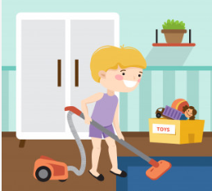


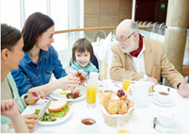

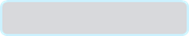
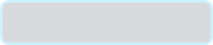


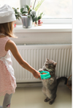
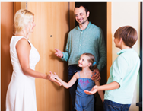



B Group the healthy and unhealthy food in the box (14*1=14 p)
muffin croissant tomato chips butter olive sausage
cheese salami egg cucumber strawberry grape

NUTRITIOUS FOOD
_________________________________________________________________________________________________________________________________________________________________
JUNK FOOD
__________________________________________________________________________________________________________________________________________________________________________________________________
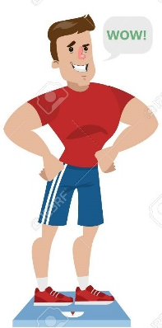
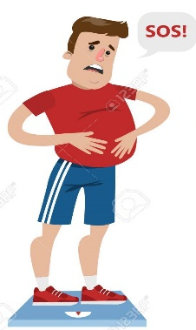

C) What time is it? Match. (Saatleri eşleştiriniz.) (10 Points)

1. (…………) 2. (………..) 3.(……….) 4.(…………) 5.(………)
A. It’s a quarter past two.
B. It’s five o’clock.
C. It’s half past three.
D. It’s half past nine.
E. It’s a quarter to eight.
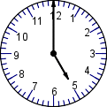
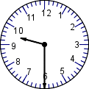
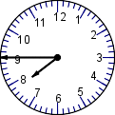
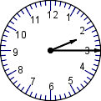
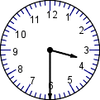

D)Fill in the blanks with “some” and “any”. ( Boşlukları “ Some” and “ Any” ile doldurunuz. (20 Points)

- There isn’t____________ milk in the glass.
- There are _______________apples in the basket.
- There is _________________water in the bottle.
- Can I have _____________more coffee? Please.
- There aren’t ________________ bananas in the fridge.
E) Circle the correct optio (Doğru seçeneği yuvarlak içine alınız.) (10Points)1.
1.He have / has breakfast at 08.00.
2. My cat drink / drinks milk everyday.
3.We don’t / doesn’t have lunch at 12.30
4.Do / Does Emre play computer game?
5.She sleep / sleeps early every evening
F)Match the breakfast with the names. WRITE THE NAMES UNDER THE PICTURES!!!! 15 pts
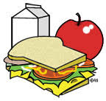
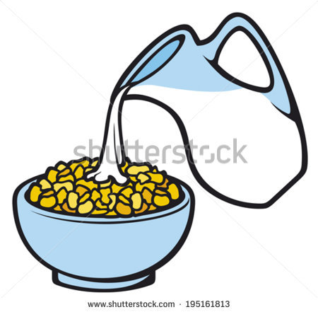
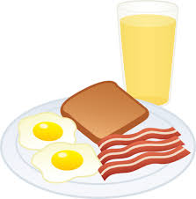
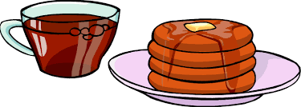
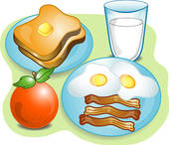

…………………… ………………………… ………………………… ………………………. ……………………….......
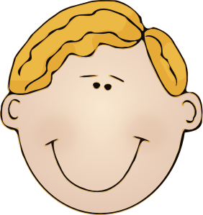
Hi! My name is Onur. I like eating eggs, sausages and toast at breakfast. My favourite drink is orange juice.

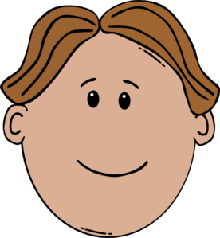
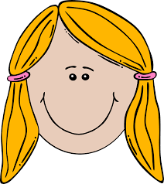


Hello! I’m Yeşim. My favourite food is pancake at breakfast and I like tea. I don’t drink milk or orange juice at breakfast.

Hello! My name is Anıl. I love eating cereal with milk at breakfast. I don’t like cheese, olives or tomatoes at breakfast

Hi! I’m Emel. I eat an apple and toast at breakfast. I don’t like tea or coffee. I like milk.

Hello! I’m Sedat. I always eat toast, eggs, sausages and an apple at breakfast. I drink milk every morning.

G)Write the correct months. (Uygun ay ismini yazınız.) (10 Points)
*December *January *June *February * October * March
*September *April * August * May * July * November



