………………………… EDUCATION YEAR …………………………………………. SCHOOL
7th GRADES 1st TERM 1stENGLISH COURSE EXAM
Name & Surname : No: Class
1.Complete the sentences below. (Aşağıdaki cümleleri tamamlayın.) (24 points)
young - clumsy - generous - wavy – ugly – punctual - tall - selfish - kind - attractive - honest - slim

- She wants everything for herself. She is ....selfish...............................
- My brother doesn’t tell lies. He is .....honest..............................
- His hair is .......wavy............................, not straight.
- I am not fat, I am ..........slim.........................
- My little brother is ........clumsy........................... He usually breaks something.
- Hey! I am ........tall..........................., not short.
- She is .......generous............................ She always gives money to people.
- My friends are not old, they are .......young..........................
- Our cat is .......ugly............................ It is not pretty.
- Wow! She is really beautiful and ........attractive...........................
- They always come on time. They are .......punctual............................
- My sister always says “thank you”. She is a ........kind........................... person.
2.Fill in the blanks with the following words.(Boşlukları aşağıdaki kelimeler ile doldurun)(10 points)
beautiful - curly - small - eyes - freckles
My friend has got brown ………eyes……………… and long ………curly……………… hair. She has got a ………small……………… nose.
She is a ……beautiful………………… girl but she has got ……freckles………………… on her face.

3.Write the comparatives of the adjectives.(Sıfatların karşılaştırmalı hallerini yazınız.) (12 points)
1. She is ………nicer than……………………………… my other friends (nice)
2. English is .......easier than................................. French. (easy)
3.Toyota cars are ……cheaper than…………………..……… Ferraricars. (cheap)
4. Lions are .....more dangerous than................ horses. (dangerous)
5. My sister is …more hardworking…………………………… my brother. (hardworking)
6. Real Madrid is ………worse than……………………… Barcelona. (bad)

4.Answer the questions using the the words in brackets. (Parantez içindeki kelimeleri kullanarak soruları cevaplayın.) (18 points)

- How often do you play tennis? (twice a day)
I play tennis twice a day.

- How often does she go to dance club? (every sunday)
She goes to dance club every Sunday.

- How often do they play golf? (never)
They never play golf.
- How often does he run? (once a day)
He runs once a day.

- How often does it sleep? (always)
It always sleeps.

- How often do you climb? (usually)
I usually climb.
5.Match the sports with the pictures. (Sporlarıresimlerleeşleştirin.) (16 points)
a. skiing b. windsurfing c. volleyball d. cycling e. roller skating
f. climbing g. scuba-diving h. skateboarding i. horse-riding j. basketball


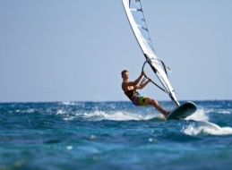
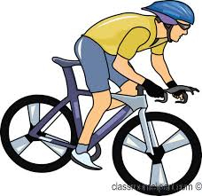
_windsurfing___________ __cycling__________ _roller skating_ __volleyball___
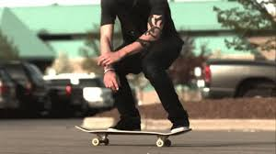
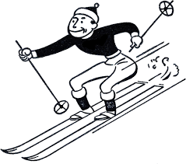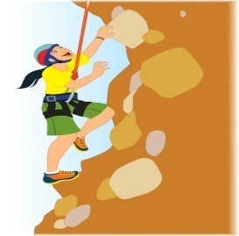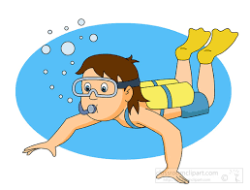
_skateboarding____ __skiing__________ __climbing___ __scuba-diving__________

- Complete the sentences according to Simple Present Tense. (Cümleleri Geniş Zaman’a gore tamamlayın. (20 points)

- Serap .......lives........................... (live) in İzmir.
- They ......aren’t have............................ (not have) breakfast at 7 o’clock.
- He ......doesn’t drink............................ (not drink) coffee in the mornings.
- We.........love......................... (love) camping.
- She ......finishes............................ (finish) the work in the evening.
- I .......don’t sleep........................... (not sleep) 10 hours a day.
- My brothers ........come.......................... (come) to Batman in summers.
- Eyüp .......doesn’t study........................... (not study) Maths.
- .Does......................... he work in the bank?
- .Are......................... they speak English?

