……………. EĞİTİM-ÖĞRETİM YILI
…………….. ORTAOKULU
6. SINIF İNGİLİZCE DERSİ 1. DÖNEM 2. YAZILI

NAME :  SURNAME :  NUMBER: | TIME : 40 MINUTES | MARK :

A)Look at the pictures and write the seasons under them (4x2= 8 points)

summer -autumn – winter - spring

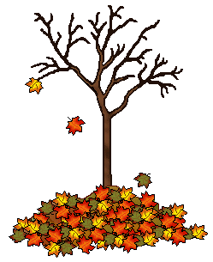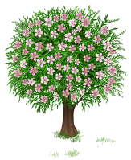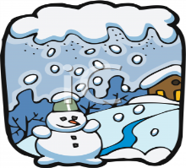

…autumn….. ….summer…. ….spring…….. ……winter……..

B) Write the comparative forms of the adjectives (4x4= 16 points)

1) Boots are ……more expensive…..…….…(expensive) than socks

2) Soup is …healthier………………..………..(healthy) than a burger

3) Your marks are …worse……………………. (bad) than Jim’s marks.

4) Elephants are……bigger………….…….. (big) than rabbits

C) Fill in the blanks with Present Sinple Tense (4x3= 12 points)

- Semih…is study……………….. (study) Enlish in the evenings.
- Duygu and I…are do…………….(do) homework together.
- Ahmet and Ali…aren’t play……. (not / play) football.
- A: Are……. you brush your teeth?
B: Yes,…I am………….…………

D) Write the time (3x4= 12 points)
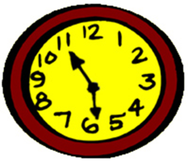
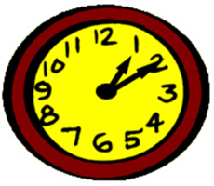
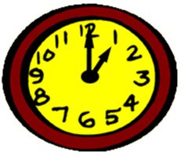

…It’s five to six………. …It’s ten past two……… …It’s one o’clock…..

E) Fill in the blanks with the forms of Present Continous Tense (4x4= 16 points)

1) You…are learning…………..…… (learn) English now.

2) My father…is having………………(have) breakfast at the moment.

3) I…am not sitting…..………………(not / sit) now.

4) …Are……….… you …sleeping……………..……..… (sleep) ?

F) Answer the questions What is the weather like? and What is the temparature?
(3x6=18 points)

1) İzmir 18 °C   2) Erzurum -12°C 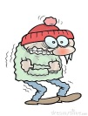  3) Bilecik 11°C  |  | 1) a) It’s sunny………………………………………..…....  b) It’s 18 C.………………………………………………  2) a) It’s cold and snowy…………………………………..…..  b) It’s -12 C……………………………………….….….  3) a) It’s cloudy……………………………………………….  b) It’s 11 C……………………………………..………..

G) Circle the correct option

Choose the correct option
(6x3=18 points)

1) Rana : ...............................?
Esen : It is eighteen degrees Celcius.

a) How is the weather?
b) How do you feel?
c) What is the weather like?
d) What’s the temperature?

2) A: ……………………………
B: Bread and cheese.

a) What time do you get up?
b) What do you eat at breakfast?
c) What time do you have breakfast?
d) Where do you have breakfast?
3) A: ………… your sister like football?
B: No, she ………………………

a) Do / don’t b) Do / do
c) Does / doesn’t d) Does / does

4)What time is it? 02.15
a. It is half past two. b. It is a quarter to two.
c. It is ten to two. d. It is a quarter past two

5) ” He usually plays football.” Cümlesinde altı çizili kelimenin sorusu hangisidir?
a) How often do you play football?
b) When does Cem play football?
c) How often does Cem play football?
d) Where do you play football?

6) There aren’t …………………… bananas.
a) any b) some c) a d) an

GOOD LUCK☺

