___________________ VOCATIONAL AND TECHNICAL ANATOLIAN HIGH SCHOOL
2024 – 2025 EDUCATIONAL YEAR 2nd TERM 1st INDIVIDUALIZED WRITTEN EXAM FOR 10TH GRADES.
Name-Surname: Class-Number:
- Match the advice with the problems. ( problemlerle tavsiyeleri eşleştir)(15x4= 60pts)
- My mom thinks I watch a lot of TV. I don’t like to miss any programs and ı watch them again and again.
- I don’t love studying. I have a lot of exams next week, and my first exam results are very bad.
- I have a terrible toothache, but I’m afraid of dentists. Two days later, I have a final exam.
- I think I’m very ugly and fat. I don’t have any friends because I think they hate me so because of my physical appearence.

- You should go on a diet and eat healthy food. Don’t be unhappy, you should make new friends.
- You should revise your subjects regularly, you can pass all of them.
- You had better have new hobbies, you should spend less time in front of TV.
- You must see a dentist immediately. You don’t have to miss the exam because of toothache.
1 _____ 2_____ 3_____ 4_____

B- Match the sentences with pictures.(Cümleleri resimlerle eşleştiriniz) (5x5=25pts)VOCABULARY
A B C D E   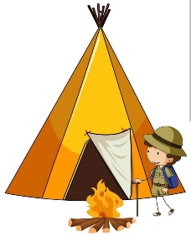 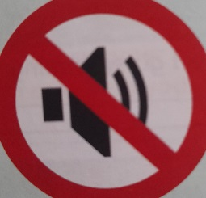 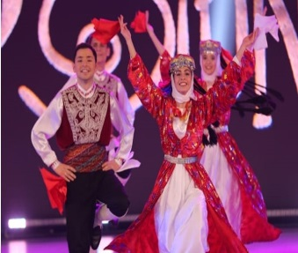
- Taj Mahal is the most popular destinations for cultural vacations. _____
- You mustn’t make noise _____
- We have stayed in a tent in on the summer nights when we were child. _____
- You have to wear mask. _____
- On 23rd April has celebrated as a Children’s Day in our country since 1923 _____

C- ‘’Boss hasn’t wanted to increase her salary,yet.’’ Cümlesinin Türkçe karşılığı nedir.(3pts)
- Patron henüz maaşını artırmak istemedi. b) Patron henüz maaşını vermedi.

D- Koyu yazılan sözcüklerden doğru olanı daire içine alın.(3x4= 12pts)
- Ömer has broken his leg, hasn’t / has he?
- They have painting / painted their living room.
- Anna’s aunt has lived in Bodrum for / since four months. GOOD LUCK

