2024-2025 EDUCATIONAL YEAR … SECONDARY SCHOOL
2nd TERM 1st INDIVIDUALIZED WRITTEN EXAM FOR 7th GRADE

NAME-SURNAME:
CLASS-NUMBER: 7/

A- YANDA VERİLEN VERİLEN KELİMELERİ BULMACADA BULUP KUTU İÇİNE ALINIZ (30P)
C | G | P | H | E | N | P | A |  | - GOOD  - PARTY  - PLACE  - PRESENT  - BALLOON  - WEDDING
L | O | U | O | I | Y | R | S |  | - GOOD  - PARTY  - PLACE  - PRESENT  - BALLOON  - WEDDING
U | O | N | U | G | E | E | T |  | - GOOD  - PARTY  - PLACE  - PRESENT  - BALLOON  - WEDDING
M | D | T | E | C | M | S | R |  | - GOOD  - PARTY  - PLACE  - PRESENT  - BALLOON  - WEDDING
S | V | T | A | T | I | E | O |  | - GOOD  - PARTY  - PLACE  - PRESENT  - BALLOON  - WEDDING
B | A | L | L | O | O | N | L |  | - GOOD  - PARTY  - PLACE  - PRESENT  - BALLOON  - WEDDING
P | P | A | R | T | Y | T | O |  | - GOOD  - PARTY  - PLACE  - PRESENT  - BALLOON  - WEDDING
W | E | D | D | I | N | G | G |  | - GOOD  - PARTY  - PLACE  - PRESENT  - BALLOON  - WEDDING

B- RESİMLERİN ALTINA İNGİLİZCELERİNİ YAZINIZ (25P) https://www.ingilizceciyiz.com/
- CAKE - COOKIES - SANDWICH - BALLOONS - PARTY HATS



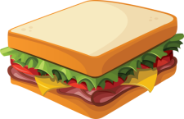
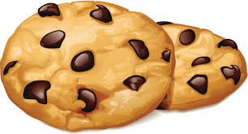


____________ ____________ ____________ ___________ ___________

C- RESİMLERİN ALTINA İNGİLİZCELERİNİ YAZINIZ (25P) https://www.ingilizceciyiz.com/
-DOCUMENTARIES - SERIES - CARTOON - QUIZ SHOW - SPORTS PROGRAM



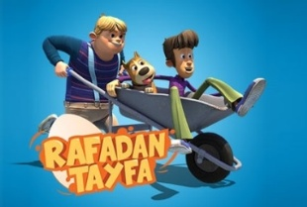
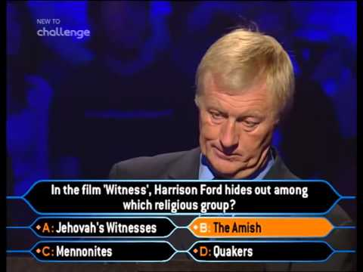
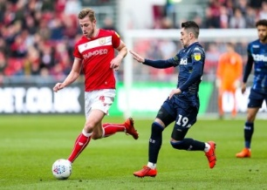

____________ ____________ ___________ ___________ ___________

D- DOĞRU SEÇENEĞİ İŞARETLEYİNİZ (20P) https://www.ingilizceciyiz.com/
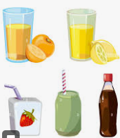
1. Sam: What do you need for the party?
Jack: I need _____________________
a) drinks b) balloons

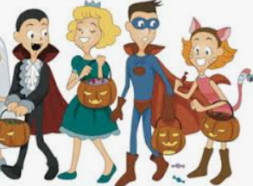
2. What kind of party is it in the picture?
a) birthday party b) costume party

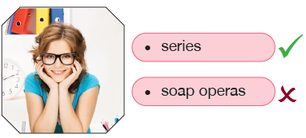
3- Resme göre doğru seçeneği işaretleyiniz.
a) Mary prefers series b) Mary prefers soap operas

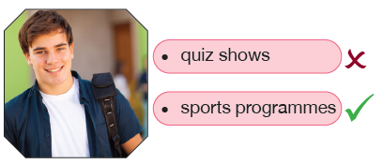
4- Resme göre doğru seçeneği işaretleyiniz.
a) Jack likes quiz shows. b) Jack likes sports programmes

https://www.ingilizceciyiz.com/

